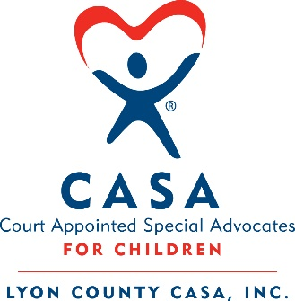 Board of Directors Candidate Application

The mission of the Lyon County CASA is to recruit, train and support court appointed special advocates so that every abused or neglected child can be safe, establish permanence and have the opportunity to thrive. All CASA board members and volunteers must pass a background check prior to working with Lyon County CASA.

Date ______________________________

Name ___________________________________________________________ First MI Last

Address ___________________________________________________________

Primary Phone _________________________ E-mail ____________________________
Relevant Experience and/or Employment and involvement in boards, committees or community activities (attach a resume if relevant) __________________________________________
______________________________________________________________________
______________________________________________________________________
______________________________________________________________________
______________________________________________________________________
Why are you interested in our organization, and how do you feel your participation on the Board of Directors will enhance the CASA program in Lyon County? ______________________________________________________________________
______________________________________________________________________
______________________________________________________________________
______________________________________________________________________
______________________________________________________________________
______________________________________________________________________

Skills, experience and interest (please check all that apply)

o Administration/Management
o Advertising/Marketing/PR
o Community Awareness
o Education
o Finance/Accounting
o Fundraising
o Grant Writing
o Healthcare/Behavioral Health
o Law Enforcement
o Legal
o Legislative
o Nonprofit Management
o Outreach/Advocacy
o Personnel/Human Resources
o Policy Development
o Program Evaluation/Data Evaluation
o Public Relations/Communications
o Strategic Planning/Program
Development
o Special Events
o Volunteer Recruitment
Other: ______________________
Other: ______________________
Other: ______________________

Please tell us anything else you’d like to share.
_______________________________________________________________________

_______________________________________________________________________

_______________________________________________________________________

_______________________________________________________________________

_______________________________________________________________________

Thank you for applying!
You will be contacted in the near future for an interview and consideration.

Please submit your application via email to
Kelcy Meyer at director@lyoncountycasa.org
Or by mail to
Lyon County CASA
P.O. Box 242
Yerington, Nevada 89447

